1/16/2023

Dhruba Saha

B.Sc Sem-v

B.Sc-(sem-v)-Comp-o4

VB-2480 of 2017-18

Digital Image Processing

Assignment 4:

1. To write and execute program for geometric transformation of image: a. Translation

%To write and execute program for geometric transformation of image: a. Translation

img = imread('src/images.jpg');

% Set translation amounts (10 pixels in x direction and 20 pixels in y direction)

tx = 10;

ty = 20;

img_translated = imtranslate(img, [tx, ty]);

figure('name','Translation','NumberTitle','off');

subplot(1,2,1)

imshow(img);

title('Input')

subplot(1,2,2)

imshow(img_translated);

title('Output')

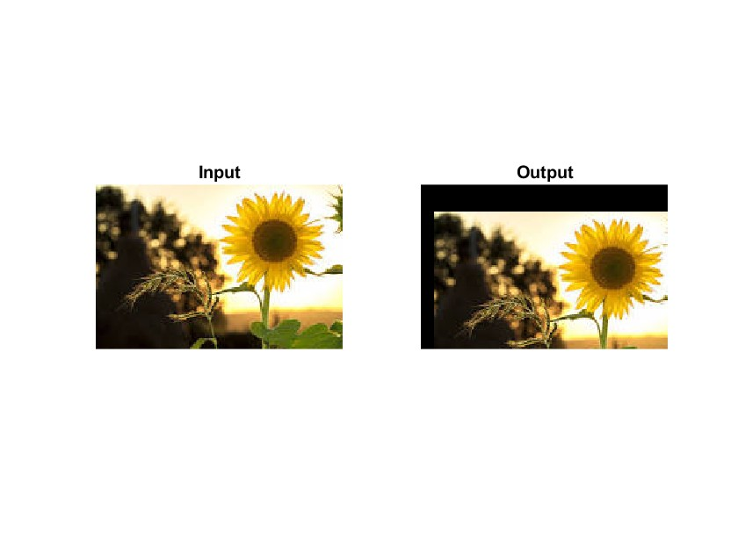

1. To write and execute program for geometric transformation of image: b. Scaling

%To write and execute program for geometric transformation of image: b. Scaling

I = imread('src/images.jpg');

% Define scaling factor

s = 2; % scale up by a factor of 2

% Apply scaling to image

I_scaled = imresize(I, s);

imwrite(I_scaled,'output_4b.png');

1. To write and execute program for geometric transformation of image: c. Rotation

%To write and execute program for geometric transformation of image: c. Rotation

img = imread('src/images.jpg');

% Define the angle of rotation in degrees

angle = 45;

% Perform the rotation

rotated_img = imrotate(img, angle);

figure('name','Rotation','NumberTitle','off');

subplot(1,2,1)

imshow(img);

title('Input')

subplot(1,2,2)

imshow(rotated_img);

title('Output')

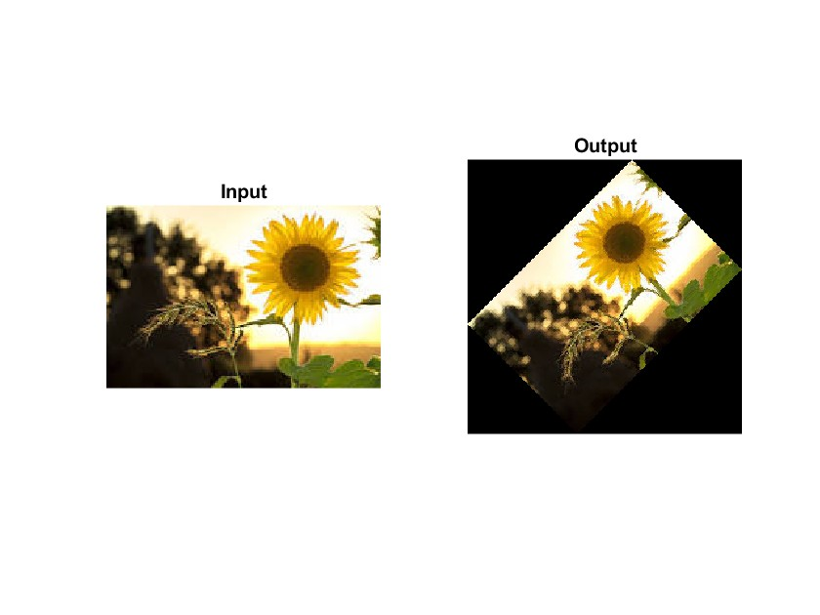

1. To write and execute program for geometric transformation of image: d. Shrinking

%To write and execute program for geometric transformation of image: d. Shrinking

img = imread('src/images.jpg');

% Define the scaling factor

scale = 0.5;

% Perform the shrinking

shrunk_img = imresize(img, scale);

imwrite(shrunk_img,'output_4d.png');

5.   To write and execute program for geometric transformation of image: e. Zooming

%To write and execute program for geometric transformation of image: e. Zooming

clear

% Load the image

img = imread('src/images.jpg');

% Define the scaling factor

scale_factor = 2;

% Zoom in on the image

new_img = imresize(img, scale_factor);

% Show the original and resized images

imshow(img);

figure;

imshow(new_img);

